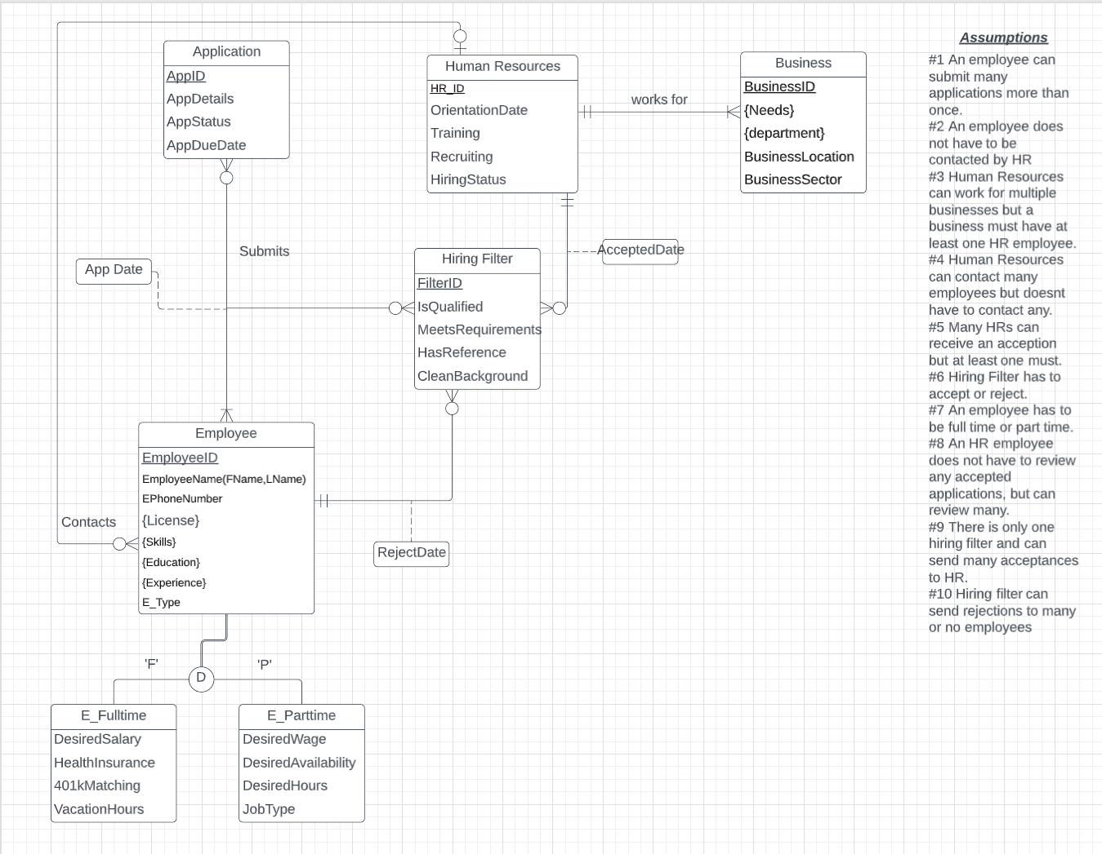

Employee: EmployeeID, EmployeeFName, EmployeeLName, EPhoneNumber, E_type, **HR_ID** [HR_ID is FK to HumanResources]

License: **EmployeeID**, License [EmployeeID is FK to Employee]

Skills: **EmployeeID**, Skills [EmployeeID is FK to Employee]

Education: **EmployeeID**, Education [EmployeeID is FK to Employee]

Experience: **EmployeeID**, Experience [EmployeeID is FK to Employee]

Application: AppID, AppDetails, AppStatus, AppDueDate

HumanResources: HR_ID, OrientationDate, Training, Recruiting, HiringStatus

Business: BusinessID, BusinessLocation, BusinessSector, **HR_ID** [ HR_ID is FK to HumanResources]

Needs: **BusinessID**, Needs [BusinessID is FK to Business]

Department: **BusinessID**, Departments [BusinessID is FK to Business]

HiringFilter: FilterID, IsQualified, MeetsRequirements, HasReference, CleanBackground, **HR_ID**, **EmployeeID**, AcceptDate, RejectDate [HR_ID is FK to HumanResources, EmployeeID is FK to Employee]

E_Parttime: **PEmployeeID**, DesiredWage, DesiredAvailability, DesiredHours, JobType [PEmployeeID is FK to Employee]

E_Fulltime: **FEmployeeID**, DesiredSalary, HealthInsurance, 401kMatching, VacationHours [FEmployeeID is FK to Employee]

Submission: (1) **AppID, EmployeeID, FilterID**, AppDate

(2) SubmissionID, **AppID, EmployeeID, FilterID**, AppDate

[AppID is FK to Application, EmployeeID is FK to Employee, FilterID is FK to HiringFilter]